Identifier:  101.01 | Revision:  0 | Effective Date:  11/8/26 |  | Exchange!
Document Catalog Number: 2016/05/05 |  |  |  | Exchange!
Author: Group 2 |  |  |  | Exchange!
User Guide

Group 2  A Piece of the Pie  3501 University Blvd, Adelpi, MD |  |  | Thanks to Yahoo! Finance

Exchange!

Copyright © 2026 [Exchange!]. All rights reserved.
No part of this publication may be reproduced, transmitted, transcribed, stored in a retrieval system, or translated into any language, in any form or by any means, electronic, mechanical, photocopying, recording, or otherwise, without prior written permission from [Exchange].
All copyright, confidential information, patents, design rights and all other intellectual property rights of whatsoever nature contained herein are and shall remain the sole and exclusive property of [Exchange] Ltd. The information furnished herein is believed to be accurate and reliable.
However, no responsibility is assumed by [Exchange] for its use, or for any infringements of patents or other rights of third parties resulting from its use.
The [Company] name and [Company] logo are trademarks or registered trademarks of [Exchange] Limited.
All other trademarks are the property of their respective owners.

Document History
Revision History
Revision Number | Revision Date | Summary of Changes | Author
1 | 5 May 5, 2016 | Initial Document | Robert Kibler
Approvals
This document requires following approvals:
Name | Title
Distribution
This document has been distributed to:
Name | Title
Group 2 | Group 2, CMSC 495, UMUC
Table of Contents
1. Introduction 6
1.1. Purpose 6
1.2. Scope 6
1.3. System Organization 6
2. Exchange! System Description 7
2.1. Key Features 7
2.2. Inventory 7
2.3. System Requirements 7
3. First time user, Starting and Stopping the System 8
3.1. First-time Users 8
3.2. Access Control 8
3.3. Installing the system 8
3.4. Starting Exchange! 9
3.5. Closing Exchange! 10
4. Exchange! Step by Step 11
4.1. Using Exchange! 11
4.2. Errors, Malfunctions, and Emergencies 13
5. Appendix A – Reference Documents 15
6. Appendix B – Glossary of Terms 16

About this guide
This document is divided into the following chapters:
- Chapter 1, “Introducing our software”.
- Chapter 2, “Key Features” gives an overview of the key features.
- Chapter 3, “Using Exchange!”, explains how to use the application.
- Glossary provides definitions of technical terms that appear in the guide.
Who Should Use It
This guide is intended for the end user of Exchange!
- Users: The guide covers System Requirements, Installation, and Application Usage.
This guide assumes that you have some knowledge basic mouse and keyboard operations.
Typographical Conventions
This document uses the following typographical conventions:
User actions appear in bold type in definitions and examples. Files and directories will also appear in bold.
Variable information appears in italic type. This includes user-supplied information in input boxes.

Introduction

Purpose
Exchange! provides the ability to quickly retrieve a currency exchange rate and convert between any two world currencies:
- Exchange! was developed to provide a simple, minimalist approach to retrieving currency exchange services where an internet browser is not readily available.
- This application was developed by Group 2 for CMSC495, UMUC.

Scope
This guide only covers the operation of the Exchange! program and will not provide any information regarding the host system. This guide assumes that the host system meets the requirements outlined in this guide and is in operational condition.

System Organization
This document applies only to the following:
- Title: Exchange! A portable currency exchange application
- Version number(s): 1.0.0

Exchange! System Description

Key Features
This application provides the ability to retrieve an exchange between any two (2) current world currencies by selecting their ISO 4217:2015 currency code. A user can also enter any valid currency amount and see the equivalent converted amount in the other selected currency

Inventory
The Exchange! application is delivered as a single executable Exchange.jar file. Upon the first execution the program will create an associated folder ExchangeDB containing a derby database used to store the currency exchange rates.

System Requirements
Exchange! requires the following:
- Java JRE 7.0 or greater
- Windows Vista SP2 or greater (Windows XP is no longer officially supported by Java)
- Mac OSX 10.7.3 or greater
- Oracle Linux 5.5+
- Ubuntu 10.0.4 or greater

First time user, Starting and Stopping the System

First-time Users
For the first time user there will be a single file named Exchange.jar
- It is recommended that you place Exchange.jar inside a folder. This application will create several additional files and folders during execution.
- A shortcut to the Exchange.jar can be used to access the application faster. Creation of this shortcut varies based on host operating system and is not covered in this guide.
- Control of the Exchange! application is through keyboard and mouse. The only keyboard input accepted by the application is number keys and control keys such as Backspace, arrow keys, and Delete.
- Internet access is required for the first time user of Exchange! The application must build the initial database of exchange rates. If Internet Access is not available on first startup, the application will notify the user and close the application.

Access Control
Exchange! is not a secure application. Ensure you received the file from a trusted source
Please read the following regarding security concerns:
- Exchange! does not store anything other than exchange rates. Amounts entered into the application are not stored or transmitted to the network.
- The Exchange! application is not secure and could be compromised. Please ensure Exchange.jar is retrieved from a trusted source as the application could be easily compromised and used as a point of entry into your system.

Installing the system
The delivered .jar file is executable and does not need to be installed. The system must have Java JRE 7 or higher installed for Exchange! to work.

Starting Exchange!
To start the Exchange! application, open the Exchange.jar executable file. For example, a Windows 10 user would Double-Click the icon as seen below.
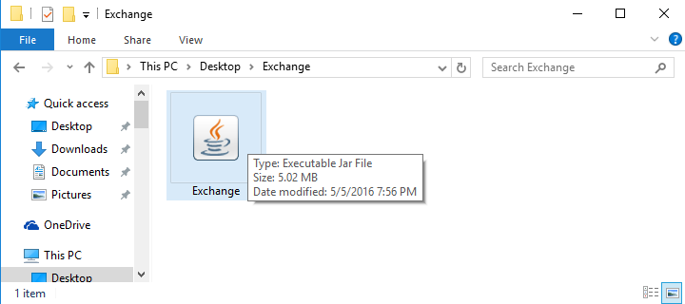

The Exchange! application will be opened and ready to use and may look like the image below.

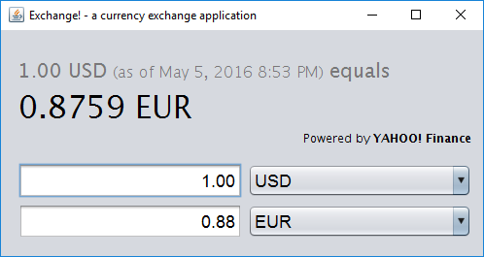

Closing Exchange!
Closing the Exchange! application will vary based on host operating system, but is a simple single button click.
- Windows Users: Left-Click on the “X” in the top right of the window as seen below
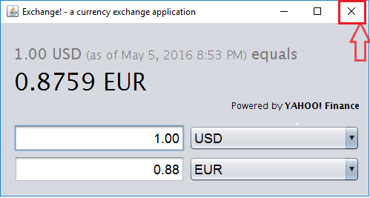

Exchange! Step by Step

Using Exchange!

Once Exchange! is open, usage is as simple as selecting your desired currencies and entering an amount.
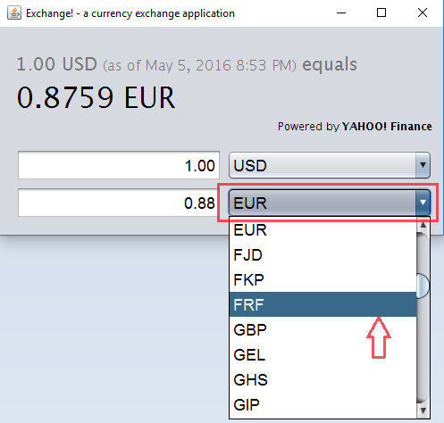
- Selecting Currencies is accomplished using the drop down menus as shown below:

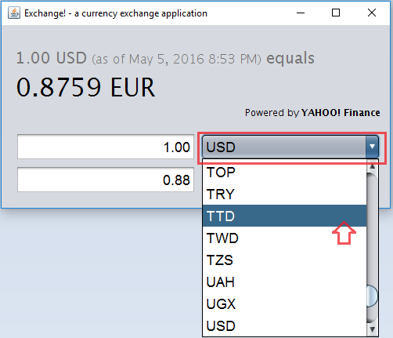

- After two (2) currencies have been selected, the exchange rate between the two will be shown along with the validity time of the currency.
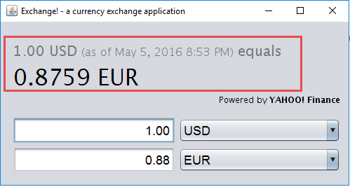

- Converting amounts is as simple as typing an amount into either entry box. The converted value will change dynamically as the amount is changed. A default value of “1” is placed in the top entry box at program startup.
Note: Currencies that do not use decimal places will not show decimal places and use standard rounding for calculations.
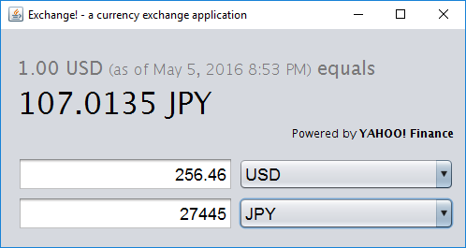

- Note: If either entry box is left blank, the entry box will be highlighted red. The entry box will also not allow any non-numeric characters to be entered.
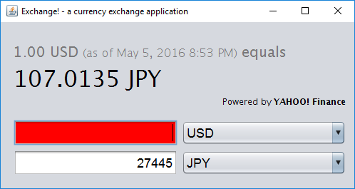

Errors, Malfunctions, and Emergencies
- Old Data: If the application is unable to connect to the internet and update the exchange rate database after 24 hours, all exchange rates will be highlighted red and the user will be notified that the rate validity is over 24 hours old.
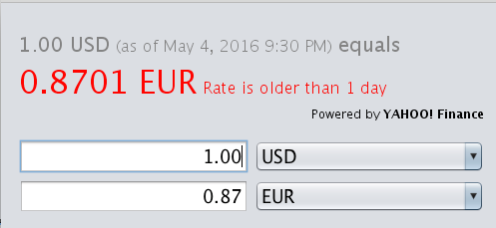

- No Connection at First Time Use: If exchange cannot connect to the internet at startup the user is notified and the application will terminate. There is no solution for this error as internet connectivity is required for first time use. The user can only click the OK button and start the application again when connectivity is restored.
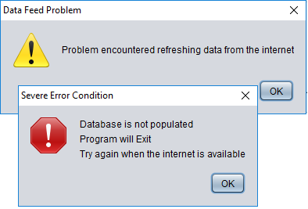

- No Connection on Startup: After the first time use the database has been initialized. If no internet connection can be made when the application is started, the user will be notified and the historically stored exchange rates will be used. If the exchange rate is older than 1 day the user will be notified as indicated in section Old Data.
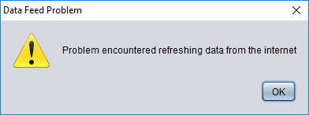

Appendix A – Reference Documents
Java 7 System Requirements - http://java.com/en/download/help/sysreq.xml
ISO 4217:2015 - http://www.iso.org/iso/home/standards/currency_codes.htm

Appendix B – Glossary of Terms
.
Term | Meaning
JRE | Java Runtime Environment. An application provided by Oracle that provides for execution of java applications.
OS | Operation System. Windows, OSX, Linux, Etc.
Database | A storage system for managing data on computers. Usually a database is stored separately from the application that uses the information stored in the database.

